Air Drag Approximation
This document outlines the methodology for approximating air drag in a drone simulation, specifically modeling the drone as a collection of standard shapes. Components, including the rotor, mounting, and main body, are represented by flat discs, spheres, and cuboids, respectively. The goal is to calculate the overall air drag force acting on the drone.

Shape Assignment:
The drone is conceptualized as a composite assembly of standard geometric shapes, each representing a distinct component such as,
- Rotor: Flat disc.
- Rotor Mounting: Sphere.
- Main Body: Cuboid.
- Connecting Arms: Cylinders.
This approach leverages well-established drag coefficients associated with these standard shapes, facilitating a streamlined and computationally efficient method for approximating air drag within the drone simulation. By systematically assigning recognized drag coefficients to individual components, the simulation benefits from the inherent simplicity and ease of integration, contributing to a realistic representation of aerodynamic forces acting on the drone. This method maintains both accuracy and computational feasibility in the simulation, making it a practical and effective approach for modeling the drone's response to air drag.
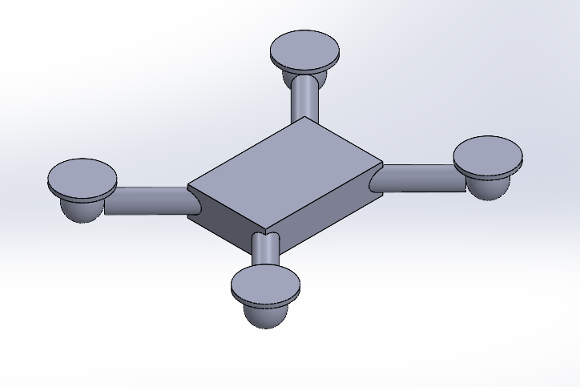
Drag Coefficient Determination:
The drag coefficients (Cd) for standard shapes are well-documented and depend on the shape and the Reynolds number (a dimensionless quantity related to the flow regime). Here are typical drag coefficients for some standard shapes that I have considered:
- Cd _{(Rotor)}: Drag coefficient for a flat disc. ≈ 1.15
- Cd _{(Rotor Mounting)}: Drag coefficient for a sphere. ≈ 0.47
- Cd _{(Main Body)}​: Drag coefficient for a cuboid. ≈ 1.05
- Cd _{(Connecting Arms)​}: Drag coefficient for cylinders. ≈ 0.82
Reference Area Calculation:
The reference area (A) is an important parameter in aerodynamics that is used to calculate drag forces. It represents the frontal area of an object as seen by the oncoming flow and is a key factor in the drag force equation. The choice of reference area depends on the specific shape of the object and the context of the aerodynamic analysis.
- A_{(Rotor)​}: Area of the flat disc.
- A _{(Rotor Mounting)}: Cross-sectional area of the sphere.
- A _{(Main Body)}​: Frontal area of the cuboid.
- A _{(Connecting Arms)}​: Cross-sectional area of the cylinders.

Drag Force Calculation:
The drag force equation expresses the aerodynamic drag force acting on an object moving through a fluid, typically air. The equation is derived from the drag force model, which considers factors such as the shape of the object (A), its velocity(v), the density of the fluid (ρ), and a dimensionless coefficient known as the drag coefficient (Cd). The general form of the drag force equation is given by:
- Drag Force _{(Rotor)} =0.5 * Cd _{(Rotor)}​ * ρ * A_{(Rotor)​} * v²
- Drag Force _{(Rotor Mounting)} ​=0.5 * Cd _{(Rotor Mounting)}​ * ρ * A_{(Rotor)​} * v²
- Drag Force _{(Main Body)} ​=0.5 * Cd _{(Main Body)}​ * ρ * A_{(Rotor)​} * v²
- Drag Force _{(Connecting Arms)} ​=0.5 * Cd _{(Connecting Arms)}​ * ρ * A_{(Rotor)​} * v²

Total Drag Force = 4*(Drag Force _{(Rotor)}) + 4*(Drag Force _{(Rotor Mounting)}) + Drag Force _{(Main Body)}
+ 4*(Drag Force _{(Connecting Arms)})

